

**Facebook Conversion API and GA4 Server-Side Tracking**

**page_view event according to GA4 schema**

**Required parameters**

The below parameters are default parameters for all events

event_id - {{Event id}}

x-fb-ck-fbp - {{fbp}}

x-fb-ck-fbc - {{fbc}}

event_time - {{Event Time}}

first_party_collection - true

**Varibales**

First party cookie - _fbp

First party cookie - _fbc

Event Time -

| function() {  return Math.round(new Date().getTime() / 1000); } |
| --- |

Event id - user-defined variable with custom template

**view_item event according GA4 schema**

**Required parameters**

event_id - {{Event id}}

x-fb-ck-fbp - {{fbp}}

x-fb-ck-fbc - {{fbc}}

first_party_collection - true

x-fb-cd-content_type

x-fb-cd-content_name

x-fb-cd-content_ids —- **The same browser side variables**

value

currency

items - {{dlv - products}} / when we need GA4 Ecommerce Tracking

**Variables**

For GA4 Enhanced Ecommerce:

dlv - products - ecommerce.detail.products

**add_to_cart event according GA4 schema**

**Required parameters**

event_id - {{Event id}}

x-fb-ck-fbp - {{fbp}}

x-fb-ck-fbc - {{fbc}}

first_party_collection - true

x-fb-cd-content_type

x-fb-cd-content_name

x-fb-cd-content_ids —- **The same browser side variables**

value

currency

items - {{ dlv - products}}

**Variables**

For GA4 Enhanced Ecommerce:

dlv - products - ecommerce.items

**begin_checkout event according GA4 schema**

**Required parameters**

event_id - {{Event id}}

x-fb-ck-fbp - {{fbp}}

x-fb-ck-fbc - {{fbc}}

first_party_collection - true

x-fb-cd-content_type

x-fb-cd-content_name

x-fb-cd-content_ids —- **The same browser side variables**

value

currency

items - {{dlv Ecommerce Items}}

**purchase event according GA4 schema**

**Required parameters**

event_id - {{Event id}}

x-fb-ck-fbp - {{fbp}}

x-fb-ck-fbc - {{fbc}}

first_party_collection - true

x-fb-cd-content_type

x-fb-cd-content_name

x-fb-cd-content_ids —- **The same browser side variables**

value

currency

user_data.email_address - {{hashed - email}}

user_data.phone_number - {{hashed - phone}}

user_data.address.first_name - {{hashed - first name}}

user_data.address.last_name - {{hashed - last name}}

user_data.address.country - {{hashed - country}}

user_data.address.city - {{hashed - city}}

user_data.address.postal_code - {{hashed - postal code}}

items - {{dlv - Ecommerce Items}}

transaction_id - {{dlv - transaction_id}}

shipping - {{dlv - shipping}}

tax - {{dlv - tax}}

affiliation - {{dlv - affiliation}}

coupon - {{dlv - coupon}}

**Event Match Quality Scrore**

**Old Method**

**User Data Variables for purchase event**

dlv - email - orderData.customer.billing.email

dlv - phone - orderData.customer.billing.phone

dlv - first name - orderData.customer.billing.first_name

dlv - last name - orderData.customer.billing.last_name

dlv - country - orderData.customer.billing.country

dlv - city - orderData.customer.billing.city

dlv - postal code - orderData.customer.billing.postcode

**User Data Variables for other events**

dlv - customerFirstName - customerFirstName

dlv - customerLastName - customerLastName

dlv - customerBillingEmail - customerBillingEmail

dlv - customerBillingPhone - customerBillingPhone

dlv - customerBillingCountry - customerBillingCountry

dlv - customerBillingCity - customerBillingCity

dlv - customerBillingPostcode - customerBillingPostcode

**New Method with GTM Kit**

**User Data Variables for purchase event**

dlv - email - ecommerce.customer.billing_email

dlv - phone - ecommerce.customer.billing_phone

dlv - first name - ecommerce.customer.billing_first_name

dlv - last name - ecommerce.customer.billing_last_name

dlv - country - ecommerce.customer.billing_country

dlv - city - ecommerce.customer.billing_city

dlv - postal code - ecommerce.customer.billing_postcode

**Server Container Configuration**

**Facebook Conversion API**

**Tag -**

Using Conversion API Tag Template

* Input Pixel ID
* Access Token
* Test Event Code just for testing purpose and please remove the code after testing the event.

**Trigger -**

Event Name - matches RegEx - ^(page_view|view_item|add_to_cart|begin_checkout|purchase)$

**Google Analytics 4**

**Tag -**

Using Google Analytics: GA4 Tag Template

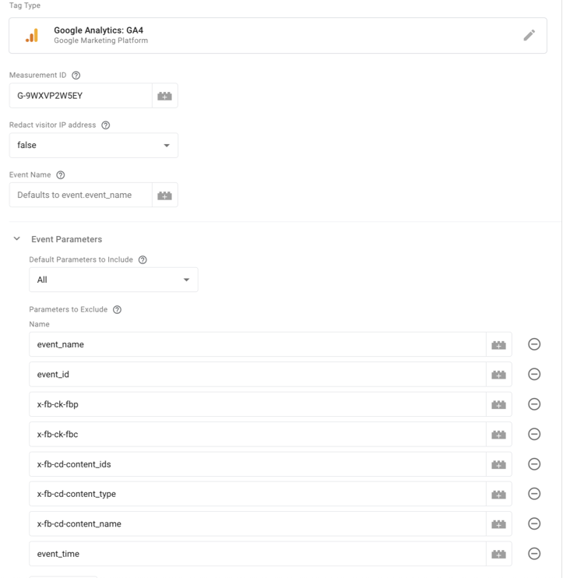

Input the GA4 Measurement ID and Exclude Facebook conversion API parameters

**Trigger -**

Client Name - equals - GA4

**Cookie Life Extender**

**Tag -**

**Cookie Monster** Tag template made by Simo Ahava

**Trigger -** GA4 Client

**Variables-**

Cookie value - _fbp

Cookie value - _fbc

Cookie value - _ga

Cookie value - _ga_Measurement ID

**6 months to Seconds** - 15778476

**2 Year to Seconds**  - 63113904

**CAPI Trigger -** page_view|view_item|add_to_cart|begin_checkout|add_payment_info|add_shipping_info|purchase

**SHA256 with Google Tag Manager**

| function() {  return sha256({{value}});    function sha256(r){if(r){r=r.toString();for(var $,_,o=Math.pow,f=o(2,32),t="length",a="",n=[],h=8*r[t],i=sha256.h=sha256.h||[],c=sha256.k=sha256.k||[],e=c[t],s={},u=2;e<64;u++)if(!s[u]){for($=0;$<313;$+=u)s[$]=u;i[e]=o(u,.5)*f|0,c[e++]=o(u,1/3)*f|0}for(r+="\x80";r[t]%64-56;)r+="\0";for($=0;$<r[t];$++){if((_=r.charCodeAt($))>>8)return;n[$>>2]|=_<<(3-$)%4*8}for(_=0,n[n[t]]=h/f|0,n[n[t]]=h;_<n[t];){var v=n.slice(_,_+=16),g=i;for($=0,i=i.slice(0,8);$<64;$++){var l=v[$-15],k=v[$-2],x=i[0],S=i[4],d=i[7]+(A(S,6)^A(S,11)^A(S,25))+(S&i[5]^~S&i[6])+c[$]+(v[$]=$<16?v[$]:v[$-16]+(A(l,7)^A(l,18)^l>>>3)+v[$-7]+(A(k,17)^A(k,19)^k>>>10)|0),p=(A(x,2)^A(x,13)^A(x,22))+(x&i[1]^x&i[2]^i[1]&i[2]);(i=[d+p|0].concat(i))[4]=i[4]+d|0}for($=0;$<8;$++)i[$]=i[$]+g[$]|0}for($=0;$<8;$++)for(_=3;_+1;_--){var w=i[$]>>8*_&255;a+=(w<16?0:"")+w.toString(16)}return a}function A(r,$){return r>>>$|r<<32-$}} } |
| --- |

*Just replace the red colour code {{value}} with the variable that you want to hash..*

**Important Urls**

**IPV 6 Template:** <https://drive.google.com/file/d/1vFG0_ZLJdYkWe0-PUhJDznLnspOQRj1c/view?usp=sharing>

***Server Deployment:***

App Engine Guide: <https://developers.google.com/tag-platform/tag-manager/server-side/app-engine-setup>

***GA4 Events and parameters:***

<https://developers.google.com/analytics/devguides/collection/ga4/reference/events?client_type=gtag#purchase>

***Shimo CAPI Doc:*** <https://www.simoahava.com/analytics/facebook-conversions-api-gtm-server-side-tagging/>